售后维修外协资质认定申请资料
Application for qualification of Bitmain official repair center

售后外协资质认证申请文件

Application Documents for Qualification Certification

资质被审核方（“申请方”）Applicant whose qualifications to be reviewed(the “Applicant”)：
注册地址Registration address ：
联系人Contact person: Mr./Miss: Sales Service Division
电话Tel: 邮件 Email：
联系地址Contact Address
认证合作涉及的地理位置 CooperationArea:

是否从事挖矿、自运维、销售和竞品业务Whether it is engaged in business regarding cryptocurrency mining, self-operation and maintenance, sales, and competitive products of BITMAIN：

认证申请必需提交的材料Documents required for qualification application:
  - 《申请方企业介绍》Introduction of the applicant
  - 《申请方的机构与组织》Applicant’s Organization Structure
  - 《营业执照（复印件）》Photocopy of business license
  - 《申请方财务信息及财务报表》Financial Statements and other required financial information
  - 《专业资质证书（复印件）》Photocopy of Engineering Certificate
  - 《外包商人力资源介绍（概述和详情）》Introduction of Human Resource Management(General and Detailed of Chief Officer)
  - 《售后代理的维修设备与设施》 Repairing Instruments and Facilities List
  - 《主要客户及合作伙伴清单》List of Customers and Cooperation Partners
认证可选的材料（如果有请提供）Optional documents for prequalification:
    - 资信证明Credit certification
    - 第三方质量、环境认证文档Copies of qualification certificates，such as ISO9001, Environmental and Occupational Health Certification Certificate, etc.
    - 过往客户推荐函Reference Letter of Past Clients
    - 附加资料Additional Information

备注Note:

认证材料需一式两份（文本和电子文档各一份），请在要求的截止时间前直接送交或邮寄至比特大陆当地办事处。

The prequalification documents shall be submitted in duplicate (One softcopy and one hardcopy). Please send or mail the copies to Bitmain local offices before the deadline.

企业介绍
Introduction of Applicant
1. 公司名称 Company name:
办公地址 Office Address:
注册地址 Registration address:
公司电话 Company Phone No.: 传真 Fax:
公司官方网址 Company Official Website: 邮编 Zip code:
2. 联系人信息 Contacts:
主要联系人姓名Primary Contact Person: 职位 Title:
手机 Mobile: 电话 Tel: 传真 Fax:
邮件 Email:
质控负责人姓名Manager of Quality control department
手机 Mobile: 电话 Tel: 传真 Fax:
邮件 Email:
销售负责人姓名Manager of Sales department
手机 Mobile: 电话 Tel: 传真 Fax:
邮件 Email:
研发负责人姓名Manager of R&D department
手机 Mobile: 电话 Tel: 传真 Fax:
邮件 Email:
- 公司简介 Company Profile (请简单描述公司整体情况，并请另附公司详细介绍文档。Please generally describe your company. For the detailed information, please attach the word/pdf/ppt document. )：
4. 可合作区域或国家Cooperation regions or countries
5. 公司注册成立时间及相关通讯从业经验（单位：年）
公司于 年成立，至今 年，有相关通讯从业经验 年。
Time of company establishment: , and till now is total years. Related handset repairing experience: years.
6.办公面积Total area of office
7.维修工厂面积Total area of factory
8.仓储面积Total area of warehouse
9.月维修产能Monthly productivity
10. Is there any quality control certificate?

公司组织架构
Applicant’s Organization Structure
请在该表写入或附上组织机构图表，说明公司的机构，包括相关董事的职位以及关键职员。Please provide or attach the organizational structure graph and describe chief officer positions.

公司组织机构图

签名 Signature:
时间 Date:

Table: Business License
公司营业执照
Business License
请在该表内列出公司的营业执照（复印件）； Please attach the business license or other equivalent corporate incorporation documents (photocopy) in this table.

签名 Signature:
时间 Date:

售后外协财务信息
Financial Statements and Other Required Financial Information
单位：元（美金）Unit: US$
1. 注册资本(美元) Registered capital (Unit: US$)

2. 过去三年每年承担维修价值以及本年度的预计维修项目价值
Annual repairing value in recent past three years and expected repairing value in this year
年度Annual |  |  |  | 本年度This year
价值Value
- 现有的工作量（项目）的大致价值 Value of current project

4. 请以附件形式附上过去三年的账目（损益表、资产负债表）以及您认为有用的其它财务数据
Please attach the accounts in the past three years, including Profit and Loss Statement and Balance Sheet and list financial data that you consider useful.
5. Names and account No of banks financially associated 公司开户银行的名称和账号
本地货币账户 For Local currency:
开户行 Open bank:

开户名 Depositor/Account name:
开户账号 Account No.:

其他货币账户（美元）For other currency ( USD )
开户行 Open bank:
开户名 Depositor/Account name:
开户账号 Account No.:
Please attach the open account certificate and bank account certificate issued by the bank.

签名 Signature:
时间 Date:

《资信证明（可选，复印件）》Credit Certification
Please provide the credit certification of your company.

《银行出具合同中的账号证明》Bank Certificate on Account Number in Contract

Please provide the bank certificate on account number in contracts.

维修资质证书
Engineering Certificate
请在该表内列出公司的专业能力资质证书（按国家本地要求提供）
Please list the Engineering Certificate (according to local requirement), and attach the photocopy.

签名 Signature:
时间 Date:

售后外协人力资源（人员－概述）
Human Resource (General)
1. 员工总人数 Number of employees:
管理人员数量 Number of Managers:
工程师人员数量 Number of Engineers:
质控人员数量 Number of Quality Control Personnel:
通过比特大陆认证的人员数量及级别 Number and levels of professionals certified by:
通过其他公司或组织认证的人员数量及级别 Number and levels of professionals certified by other company:
2. 请列出公司现有的董事（或最高管理层）Please list current directors or top management layer.
姓名Name: 现任职 Current position:
联系方式 Contract Way:
手机 Mobile phone: 邮件 Email:
3. 请列出相关的其他接口人员信息 Please list the other contact persons associated
姓名Name: 现任职 Current position:
在本公司年数Work experience in the current company: years , 从业时间 and total work duration: years.
工作语言 Working language:
手机 Mobile phone: 邮件 Email:

姓名Name: 现任职 Current position:
在本公司年数Work experience in the current company: years , 从业时间 and total work duration: 1 years.
工作语言 Working language: 中文
手机 Mobile phone: 13640995460 邮件 Email: wealthwu@hnhaochengxin.cn
签名 Signature:
时间 Date:

售后外协维修设备及设施清单
Repairing Instruments and Facilities List

经第三方认证的质量保证体系
Quality Assurance Certificate Granted by aThird Party
请描述公司的第三方认证质量保证体系（复印件）（请附企业相关的质量标准）
Please describe quality assurance systems granted by a third partiy of your company and provide the certificate and related quality standards.
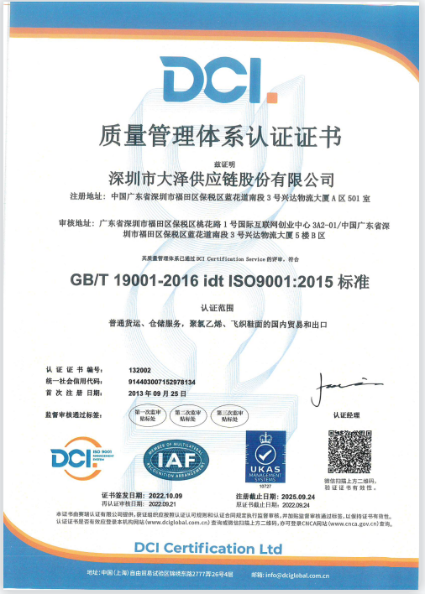

签名 Signature:
时间 Date:

已通过的环境、职业健康认证证书
Environmental and Occupational Health Certification Certificates
请描述公司的健康、环境一体化体系 （请附企业相关制度、标准，（复印件））
Please describe integrated environmental and occupational health systems of your company and provide photocopies of certificates, documents of related systems and standards.

无

签名 Signature:
时间 Date:
List of Customers and Cooperation Partners
主要客户及合作伙伴清单
List of Principal Customers and Cooperation Partners
请列出公司主要客户清单 Please list pricipal customers of your company.

无

签名 Signature
时间 Date:

过往客户推荐函
Reference Letter of Past Clients
请附加公司的重要客户的推荐函
Please provide reference letters of past customers of BITMAIN for your company.

无

签名 Signature
时间 Date:

附加资料
Additional Information
请描述 Please submit:
公司在过去的三年至今涉及的诉讼或仲裁，请对每年发生的诉讼或仲裁涉及的原被告（申请人或被申请人）名称、诉讼原因（包括但不限于合同纠纷、侵权、知识产权、商标、专利、刑事案件等）、争端事件、争议的金额，公司是胜诉或是败诉。
Please describe lawsuits and arbitration of your company in the past three years to date. Please provide name of the plaintiff and the defendant (the applicant or the respondent), causes of action (including but not limited to contract dispute, infringement, intellectual property, trademark, patent and criminal cases, etc.), dispute events, and amount in disputes involved in the lawsuits and arbitration and results of the lawsuits and arbitration.

请提交其他必要说明 Other information if necessary:

签名 Signature:
时间 Date:

NO：

